Southern Tier Chapter of
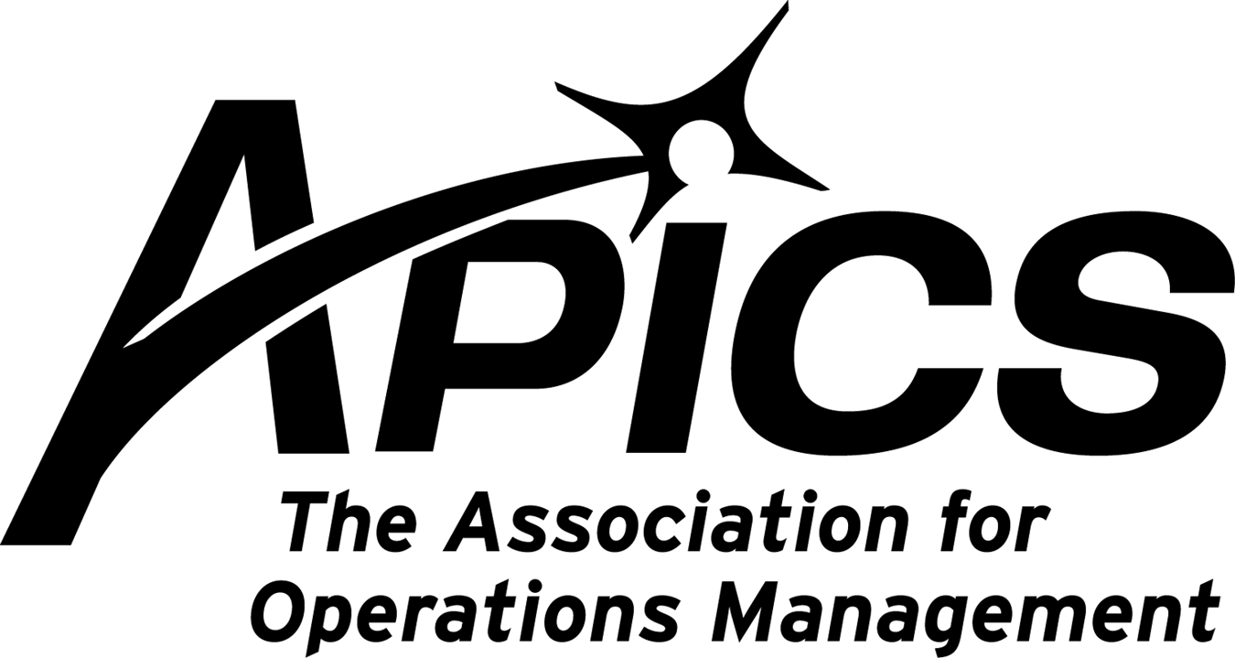

“Advancing productivity and innovation and competitive success.”

STAPICS May Professional Development Meeting

Explore a century of information technology from the 1880’s to the 1980’s at the IBM Endicott History & Heritage Center at 1701 North Street in Endicott.

Wednesday, May 5, 2010
6:00 pm
Member Appreciation Night to follow. Look for details soon.
Free to members and their guests.

Reservations requested by April 28th.

Contact Mike LoSapio by phone at 607-786-3487 or email at michael.losapio@synergyresources.net

Binghamton University, AM&T, and Visions FCU
PRESENT
a Southern Tier Opportunity Coalition (STOC)

SUPPLY CHAIN WORKSHOP

USING YOUR SUPPLY CHAIN TO BUILD DEMAND

Learn how to "sell" to supply chain experts who are replacing the traditional buyer and re-buyer roles in your customer organizations. This new buyer has been trained in the science of operations and resource management and is looking for supply solutions, not just low cost materials and services.

Workshop take-aways:
1) What is important to your customers supply chain functions?
2) What are the critical metrics used in today's customer sourcing decisions?
3) How do you appeal to your customers needs?
4) What, beyond price, is critical to selling your product in the future?
5) How can companies in the Binghamton and surrounding areas learn of each others capabilities?
The work shop will feature three guest speakers who will present their views on how to create new demand for your product/services in this new and ever changing market place.
The speakers are as follows:
Joe Yacura - Supply Chain Management, LLC will discuss how to sell to this new generation buyer. Joe's presentation will be based on his experience both in the manufacturing and service sectors where he led supply management functions with annual purchasing budgets in excess of $9B annually.

Steve Whited - MeadWestvaco. For over 15 years, MeadWestvaco (MWV) Consumer and Office Products in Sidney, NY has been using Collaborative Planning Forecasting and Replenishment (CPFR) to reduce stock-outs, improve sales and minimize costly overstocks for its key customers (Staples, Office Max and Office Depot). The bulk of MWV's office products business is in calendars and dated planning products. Combining the highly seasonal nature of MWV's demand with its level loaded production schedule makes forecasting a key to profitability for MWV and its customers. Learn from discussion with Steve Whited, Manager of Replenishment,how MWV has madeCPFR a cornerstone of its customer value proposition.

Patrick Rogan - MeadWestvaco. Patrick, a STOC Board Member and STOC's Supply Chain Initiative Lead, will discuss plans for a Greater Binghamton regional vendor network using the tagline "Buy Locally, Sell Globally". Employing local suppliers makes good business sense as companies strive to become lean enterprises. As energy costs increase, the transportation element will become a larger portion of total supply chain costs, making local suppliers more valuable. STOC plans to work with larger regional businesses and examine opportunities to re-direct spend going outside the region, back into Greater Binghamton. Eventually Pat's team hopes to build upon successes and create a regional strategic vendor base for Greater Binghamton's mid-sized and large companies.
Format:
3 presenters in 3 back to back sessions (10 - 15 minutes between sessions)
Session duration - 45 minutes each
For reservations,
Online Registration Form
or contact STOC Administrative Assistant Natalia Czabala at
nczabala@gmail.com or (607) 772-8863 x5

STOC and Binghamton University, AM&T and Visions Federal Credit Union
invite you to spend a morning discussing these and other ways we might work together as business leaders to grow our businesses and in the process improve regional economic conditions. Please see the registration form for more information or go on-line to www.stoc-ny.com. Thank you.

All ARE WELCOME!

Invite your friends and co-workers!
Forward this e-mail to whomever
you believe would be interested.

Southern Tier Opportunity Coalition
Supply Chain Workshop
DATE: Monday, April 26
TIME: 8:30 AM - 12 PM
LOCATION: Binghamton University Campus,
Knoll-MacDonald Watson Commons
(EB H-5) in the Engineering Building

Southern Tier Opportunity Coalition
Couper Administration Building Room 127
Binghamton University PO Box 6000
Binghamton, New York 13902-6000
607-772-8863 ext. 5

Resume Tips: Five Ways to Grab Employers' Attention

With today's level of competition for good jobs your resume has got only one chance to make a great first impression. To be considered for interviews your resume must have that special something that grabs the reader's attention and motivates them to call you. Here are five strategies for transforming a blah document into a WOW resume that will get employers calling you.

1. Keep your focus clear and to the point.

The first thing potential employers need to know is what you do and the position you are interested in. In the past job seekers have used an objective statement at the top of their resume to indicate their employment interest. With the lightning speed scanning approach that recruiters take in viewing resumes, a wordy, vague objective statement taking up three or more lines of text just doesn't get the job done. In most cases they don't get read.

Instead, write a short, direct professional summery that clearly illustrates your career focus. Your statement should include your profession, how long you've done it and your particular areas of expertise. Something to the effect of:
Senior purchasing professions with 10 years' procurement expertise in: strategic sourcing, contract negotiation, financial analysis, strategic planning, leadership, contract law and process improvement.

Remember, your resume is not an historical tell-all. To keep your focus clear make sure that everything following in your resume relates to your focus. Leave off extraneous details.

2. Stuff your resume with key words.

The more key words you use the more frequently your resume will show up in online searches like LinkedIn, TheLadders and CareerBuilder, etc.. Additionally, employer resume data bases also use key words to query for qualifying candidates. Without appropriate key words your resume will be electronically ignored. Without key words, your resume is being shot off into a black void each time you submit it.

A good way to make sure your resume is full of key words is to check it against job postings. Use as many of the key words found in the responsibilities and qualifications sections of job postings. As much as you can, match up your terminology with what you find in job postings.

3. Keep your resume reader-friendly.

Nothing gets ignored like a resume full of lengthy blocks of text. No one has time to read through that much information. Resume screeners need to be able to absorb your information quickly. Leave out extraneous details so that key facts show up easily. Separate blocks of text into smaller easy-to-digest snippets of information. Use white space to separate bullet points so that each stand out. Be sure that your font size is readable: nothing smaller than 11 point.

4. Include plenty of accomplishments.

If you want to stand out from the crowd you must include accomplishments throughout your resume. Write accomplishments that show how you solve universal problems such as saving time, cutting costs, improving performance and increasing customer satisfaction. Your accomplishments should stand out on your resume in bullets separate from your responsibilities. Don't make the common mistake of combining responsibilities and accomplishments in a long list of bullets. List your responsibilities in a small block of text and your accomplishments in bullet form following.

5. Get your best information on page one.

It's true, if you can't grab their attention on page one they won't stick it out to find out the wonderful things you've got on page two or three. This presents a problem for those who experienced their most productive work five or more years back. The solution is to use the hybrid resume format that allows you to create a highlight of accomplishments section at the top of page one of your resume. This area of your resume is reserved for the best examples of your work. The accomplishments you include should illustrate the key transferable skills needed for the position you are interested in.

Don't delay in implementing these resume changes. Employers are waiting for you with opportunities for a better career and a better life.

~~~~~~~~~~~~~~~~~~~~~~~~~~~~~~~~~~~~~~~~~~

Deborah Walker, Certified Career Management Coach
Read more career tips and see sample resumes at:
www.AlphaAdvantage.com

Educational Opportunities!!!

BASICS OF SUPPLY CHAIN MANAGEMENT – 1st in CPIM Series

We are planning to run a Basics of SCM course on Friday mornings, beginning May 7th, 2010,
in Sidney NY. We plan to open 2 spots (subject to availability) to the general public at regular pricing.
For more information contact:
Patrick Rogan, CPIM Associate Instructor
Senior Supply Chain Manager
MeadWestvaco Consumer & Office Products
101 O’Neil Road
Sidney, NY 13838
(607) 561-5702
patrick.rogan@mwv.com

If april showers bring mayflowers, what do mayflowers bring?

Pilgrims!

Your 2009-2010 Board of Directors

President Dave Gardner dgardner@akraturn.com
Education Director Don Sheldon dsheldon@sheldoninc.com
Secretary Deb Unkel deb.unkel@raymondcorp.com
VP Membership Lee Schechter lschechter@stny.rr.com
VP Programs Michael LoSapio Michael.losapio@synergyresources.net
Executive VP /Director of Finance Steve Whited sjw6@meadwestvaco.com
Web site Michael LoSapio
Publicity / Marketing Kelly Noreika Kelly.noreika@lmco.com

Southern Tier APICS
PO Box 1107
Binghamton NY 13902-1107

